Robot-based Automated Isolation and Characterization of a Colicin-producing Escherichia coli-strain with Inhibitory Effect on EPEC

Beate Heilmann, Saban Özipek, Luca Stähelin, Marvin Machava, Peter Götz, Johannes Bader*, Elisabeth Grohmann

University of Applied Sciences (BHT), Berlin, Biotechnology, Seestraße 64, 13347 Berlin

bader@bht-berlin.de

In the presented article, isolation of an antimicrobial Escherichia coli (E. coli) strain from municipal wastewater using high-throughput methods by automated liquid handling is described. The effect of the substance, which is mainly present intracellularly, is directed against the enteropathogenic E. coli (EPEC). Subsequent production and purification of the antimicrobial active substance allowed its identification as colicin. This finding is supported by the detection of three different colicin genes in the isolated E. coli strain.

**1. Introduction**

Since antibiotic resistance is growing at alarming rates, causing a global health threat, there is an urgent need for the development of innovative strategies for the discovery of new antibiotic substances (Miethke et al. 2021). While former strategies for antimicrobial drug discovery mainly focused on synthetic chemicals, modern approaches are now returning to the investigation of natural resources (Song, 2022). Recently, colicins are regaining attention as potential alternatives to traditional antibiotics (Cherier et al. 2021). Colicins are antimicrobial proteins produced by E. coli strains that inhibit or kill bacteria closely related to the producing strain with high specificity (Cascales et al. 2007).

The spread of antibiotic-resistant bacterial strains poses a serious threat to all humans. The European Center for Disease Prevention and Control specifically warns about resistant E. coli strains. Here, resistances to reserve antibiotics such as carbapenems have increasingly occurred (WHO, 2023). According to the European Antimicrobial Resistance Surveillance Network (EARS-Net), more than half of the reported isolates are resistant to at least one of the examined antibiotic groups (carbapenems, aminoglycosides, 3rd generation cephalosporins, fluoroquinolones, and aminopenicillins) (ECDC 2017). This poses a great risk, as E. coli is one of the most common pathogens causing sepsis and urinary tract infections (ECDC 2017). Critical are especially carbapenemase resistant bacteria (Aurilio 2022) and Extended-Spectrum-Beta-Lactamases (ESBL) forming E. coli strains. ESBLs are hydrolytic enzymes that cleave the ß-lactam ring of antibiotics such as penicillins, cephalosporins, and aztreonam, thus rendering them ineffective (Fenner et al. 2008). They differ from conventional ß-lactamases by a much broader substrate spectrum, which arose through mutations (Witte 2003). Infections from ESBL formers are often very difficult to combat, which is why reserve antibiotics must be used more frequently. The spread of ESBL formers like E. coli ST131 C1-M27 is alarming. Its frequency in human isolates from Germany was still 0% in 2009, but rose to 45% by 2016 (Gosh et al. 2017). In poultry farming, the Netherlands is particularly affected by ESBL formers, so in 2012 100% of conventionally farmed and 84% of organically produced chicken meat tested positive for ESBL formers (Cohen et al. 2012).

The commercially available antibiotic colistin has so far proven to be a very reliable reserve antibiotic if regular antibiotics such as ß-lactams and aminoglycosides no longer showed any effect. The first colistin resistance mediating gene mcr-1 was detected in China (Liu Y. et al. 2016). The gene was most frequently detected in isolates from livestock farming, where colistin is often used (Liu Y et al. 2016). The studies from China refuted the previously valid assumption that colistin resistance could not be transferred (BfR 2016). The spread of the mcr-1 gene is also alarming. In pig farming operations, colistin resistance has already been detected in ESBL formers (Lay et al 2021). Their further spread seems inevitable. Resistant coliform bacteria are not only found directly at the site of selection pressure. They spread mainly via the water cycle and usually enter rivers and lakes via wastewater from hospitals or livestock farming (Berglund et al. 2023). Sewage treatment plants are not able to remove all resistant pathogens from the wastewater, which can thus enter surface waters (Korzeniewska et al. 2013). Fertilizing fields with cattle or chicken manure also leads to the release of resistant E. coli strains (Hartmann et al. 2013). The spread via migratory birds, such as geese and cranes, has also already been proven. Transmission to humans can occur through contaminated drinking water, contact with infected persons, and through contaminated food. The WHO estimates the danger posed by resistant enterobacteria as critical and gives top priority to the discovery and development of new antibiotics (WHO, 2023)

Given the urgency to develop new antibiotics against resistant E. coli strains, the class of substances known as colicins is gaining importance again. Colicins are 20-80 kDa large proteins, which are formed by some E. coli strains and are toxic to other E. coli strains (Cascales et al. 2007). Colicin-forming strains thus have a specificity for other strains of the same species. They act extremely specifically, so only strains with specific surface receptors are sensitive. These target surface receptors of the colicins are eponymous, e.g., Colicin E binds to the surface receptor E. If several different colicins bind to the same receptor, they are numbered. The colicins must bind to the surface receptors in order to exert/perform their effect. There are different mechanisms of action, all of which lead to the death of the sensitive strains. Colocin K inhibits the synthesis of macromolecules, Colicin E2 causes DNA damage and Colicin E3 prevents protein synthesis. Colicins can be extremely efficient, often the contact of a single colicin molecule is enough to kill the target organism. This is referred to as a single-hit mode of action. The genes encoding the colicins are located on plasmids. One of their most important regulatory factors is the LexA repressor, which makes their expression inducible by the SOS response.

To approach the urgent task to identify new antimicrobial substances, environmental samples have been screened for antimicrobial activities. Furthermore, antimicrobial activity testing and purification of the antimicrobial substance are described in the following sections of the publication.

**2. Material and Methods**

Isolation of the antimicrobial acting E. coli strain from sewage sludge from a wastewater treatment plant in Berlin, Germany was done by the following steps:

1. Isolation of the microorganisms from the biofilm in the sludge was achieved by ultrasonication of 1 mL samples at 23 °C for 20 minutes.
2. Decadic dilution of the samples in 96 well plates in triplicate with the liquid handling system PIPETMAX (Gilson, Middleton, USA)
3. Incubation for 48 h at 37 °C in 30 g/L caso- bouillon with shaking (Carl Roth, Karlsruhe, Germany), pH = 7.3
4. Measurement of microbial growth by reading the optical density at 600 nm

Antimicrobial activity testing was performed with the agar diffusion test against enteropathogenic E. coli (EPEC). Positive candidates were purified in order to get pure cultures for further experiments. Identification of the isolated strains was conducted by MALDI Biotyping using the MALDI UltrafleXtreme™ (Bruker, Billerica, USA).

Isolated strains were cultivated at 37 °C with shaking for 16 hours. The culture was diluted with caso-bouillon (Carl Roth, Germany) to an OD600 of 1. After the addition of1 µg/mL mycomycin C for increased induction of colicin production incubation continued for two hours. Cells were harvested at 10,000 x g for 5 minutes. Lysis of cells was done with the cell pellets in 3 mL lysis buffer: 5% (v/v) glycerol, 50 mmol/L Tris, pH 7.5 by ultrasonication for 5 minutes on ice. Cells and cell debris were removed by centrifugation for 15 minutes at 10,000 x g and sterile filtration. Evaluation of colicin production was done by agar diffusion assays in triplicate against an EPEC strain (culture collection of BHT). Total protein concentration was determined by a Bradford assay (Bradford 1976). Purification of the colicin was done with the following methods:

1. Heat precipitation: 10 minutes at 50 °C and 10 minutes 60 °C. Afterwards; colicin was in the supernatant
2. Ion exchange chromatography: Capto DEAE (Cytiva, Marlborough, USA), 20 mmol/L Tris, pH = 7.5, Äkta-Start system (Cytiva, Marlborough, USA), elution with a linear NaCl gradient up to 0.5 M.
3. Ammonium sulphate (AS) precipitation: precipitation of colicin at 60% of saturation on ice for 2 hours, after centrifugation at 10,000 x g for 5 minutes, colicin was in the pellet
4. Hydrophobic Interaction Chromatography: Hitrap Butyl FF (Cytiva, Marlborough, USA), running buffer: 1 mol/L AS in 50 mmol/L sodium phosphate, pH = 7, elution with decreasing AS-gradient, using the Äkta-Start system (Cytiva, Marlborough, USA)

**Results and Discussion**

The isolated E. coli strain (EC2) was able to produce a substance with an activity against EPEC (Figure 1). The produced substance was not, or only in a very low amount, secreted because the supernatant did not show a clear zone in the agar diffusion assay. Only the lysates of the cells formed a clear zone. The addition of mitomycin C increased the intracellular concentration of colicin compared to the untreated cells. This induction by mitomycin C was a first hint that the substance might be a colicin, produced by the isolated E. coli strain.

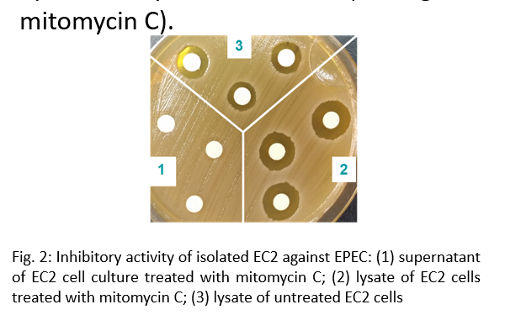

*Figure 1: Inhibitory activity of isolated E. coli strain (EC2) against EPEC: (1) supernatant of EC2 culture treated with mitomycin C; (2) lysate of EC2 cells treated with mitomycin C; (3) lysate of untreated EC2 cells*

For the identification of the EPEC inhibiting substance it was purified by a series of different methods (Table 1). These methods include a heat precipitation, an anion exchange chromatography, an ammonium sulphate precipitation, followed by a hydrophobic interaction chromatography. For the evaluation of the purification methods, inhibitory activities of the fractions were determined by agar diffusion test. The results of these tests are summarized in Table 1. Furthermore, the total protein content could be reduced by a factor of 99, indicating a very efficient downstream process.

*Table 1: Zone of inhibition given as diameter in mm of selected samples from downstream purification process. HP: heat precipitation, IEC ion exchange chromatography, WO: wash out, ASP ammonium sulphate precipitation, HIC: hydrophobic interaction chromatography; AS: ammonium sulphate; *presented diameters include the diameter of the disk of 6 mm.*

|  |  |
| --- | --- |
| **Sample / fraction** | **Inhibition Zone (mm)\*** |
| EC2 cell lysate | 14 |
| HP supernatant | 14 |
| IEC fr. 1 - 2 | 0 |
| IEC fr. 3 | 7 |
| IEC pool fr. 4 - 8 | 12 |
| IEC fr. 9 | 0 |
| IEC WO | 0 |
| ASP supernatant | 0 |
| ASP pellet | 10 |
| HIC 60% AS fr. 1 | 0 |
| HIC 60% AS fr. 2 | 12 |
| HIC 60% AS fr. 3 | <7 |
| HIC 60% AS fr. 4 | <7 |
| HIC 60% AS fr. 5 - 7 | 0 |
| HIC 60% AS WO | 0 |

Up to this point, there was only the assumption that the antimicrobial belongs to the colicins. To confirm this assumption, the microorganism was examined for the presence of colicin genes using PCR. The genes for colicins B, E1, and M were detected in the EC2 isolate (Figure 2).

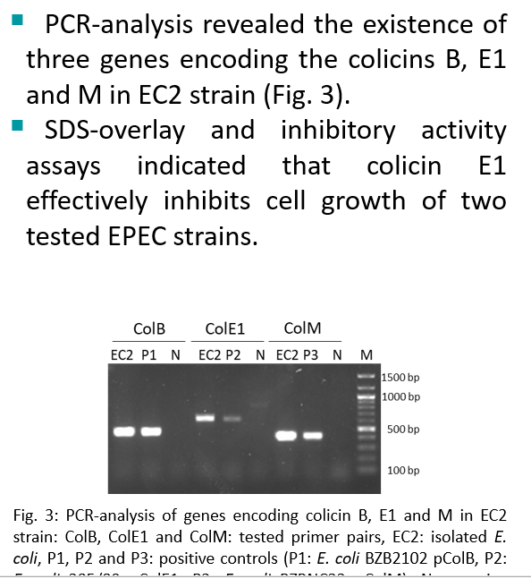

*Figure 2: PCR-analysis of genes encoding colicin B, E1 and M in EC2 strain: ColB, ColE1 and ColM: tested primer pairs, EC2: E. coli isolate, P1, P2 and P3: positive controls (P1: E. coli BZB2102 pColB, P2: E. coli 385/80 pColE1, P3: E. coli BZBNC22 pColM), N: negative control (E. coli BL21), M: 100 bp ladder*

**Conclusion:**

The application of an automated high-throughput screening assay allowed the isolation of an E. coli strain from wastewater sludge with inhibitory properties on EPEC. Purification of the inhibiting substances indicated that the relevant substance belongs to the colicins. This assumption was proven by PCR-analysis which indicated the presence of three colicin genes in the isolated strain. The presented work can be the basis for further robot-based research to identify new antimicrobial substances. Hence, this work can help to overcome the increasing health problems due to multiresistant microorganisms.

**Acknowledgement:**

The presented work was funded by the European Union “European Regional Development Fund”.

**References:**

Aurilio C., Sansone P., Barbarisi M., Pota V., Giaccari L.G., Coppolino F., Barbarisi A., Passavanti M.B., Pace M.C. (2022) Mechanisms of Action of Carbapenem Resistance. Antibiotics (Basel), 11 (3) 421. doi: 10.3390/antibiotics11030421.

Berglund, F., Ebmeyer, S., Kristiansson, Larsson D.G.J.*, 2023,* Evidence for wastewaters as environments where mobile antibiotic resistance genes emerge. *Communications Biology* 6, 321. https://doi.org/10.1038/s42003-023-04676-7

BfR, 2016, Übertragbare Colistin-Resistenz in Keimen von Nutztieren in Deutschland, Bundesinstitut für Risikobewertung, http://www.bfr.bund.de/de/presseinformation/2016/01/uebertragbare_colistin_resistenz_in_keimen_von_nutztieren_in_deutschland-196144.html, accessed 19.12.2023.

Bradford M.M., 1976, A rapid and sensitive method for the quantitation of microgram quantities of protein utilizing the principle of protein-dye binding. Analytical Biochemistry. 72, 248 – 254.

Cascales E., Buchanan E.K., Duché D., Kleanthou C., Lloubès R., Postle K., Riley M., Slatin S., Cavard D., 2007, Colicin Biology, Microbiology and Molecular Biology Reviews, 71, 158 – 229.

Chérier D., Patin D., Blanot D., Touzé T., Barreteau H., 2021, The Biology of Colicin M and Its Orthologs. Antibiotics (Basel). 10 (9) :1109, doi: 10.3390/antibiotics10091109.

Cohen J., van den Munckhof T., 2012, Comparison of ESBL contamination in organic and conventional retail chicken meat. International Journal of Food Microbiology 15 (3) 212 - 214.

ECDC, 2017, EARS-Net surveillance data “Summary of the latest data on antibiotic resistance in the European Union” European Center for Disease Prevention and Control, Stockholm. https://www.ecdc.europa.eu/en/publications-data/summary-latest-data-antibiotic-resistance-european-union. accessed: 21.12.2023.

Hartmann A., Locatelli A., Amoureux L., Depret G., Jolivet C., Gueneau E., Neuwirth C., 2012, Occurrence of CTX-M Producing Escherichia coli in Soils, Cattle, and Farm Environment in France (Burgundy Region), Frontiers in Microbiology 3, 83.

Korzeniewska E., Harnisz M., 2013, Extended-spectrum beta-lactamase (ESBL)-positive Enterobacteriaceae in municipal sewage and their emission to the environment, Journal of Environmental Management 128, 904-911.

Lay K.K., Jeamsripong S., Sunn K.P., Angkititrakul S., Prathan R., Srisanga S., Chuanchuen R., 2021, Colistin Resistance and ESBL Production in *Salmonella* and *Escherichia coli* from Pigs and Pork in the Thailand, Cambodia, Lao PDR, and Myanmar Border Area. Antibiotics (Basel), 10 (6) 657. doi: 10.3390/antibiotics10060657.

Liu Y.Y., Wang Y., Walsh T.R., Yi L.X., Zhang R., Spencer J., Doi Y., Tian G., Dong B., Huang X., Yu L.-F., Gu D., Ren H., Chen X., Lv L., He D., Zhou H., Liang Z., Liu J.-H., Shen J., 2016, Emergence of plasmid-mediated colistin resistance mechanism MCR-1 in animals and human beings in China: a microbiological and molecular biological study, The Lancet Infectious Diseases 16 (2) 161 - 168.

Miethke M., Pieroni M., Weber T. *et al.*, 2021, Towards the sustainable discovery and development of new antibiotics. *Nature Reviews Chemistry* **5**, 726–749, https://doi.org/10.1038/s41570-021-00313-1WHO, 2023, Antimicrobial Resistance, https://www.who.int/news-room/fact-sheets/detail/antimicrobial-resistance accessed: 09.01.2024.

Song F., 2022, Antimicrobial Natural Products. Antibiotics (Basel), 11 (12), 1765, doi: 10.3390/antibiotics11121765.

WHO, 2023, Antimicrobial Resistance, https://www.who.int/news-room/fact-sheets/detail/antimicrobial-resistance accessed: 09.01.2024.